**1. InventoryManagementSystem**

**Main.java**

import java.util.HashMap;  
import java.util.Scanner;  
public class Main {  
 public static HashMap<Integer, Product> *productList*=new HashMap<>();  
 public static void main(String[] args) {  
 Scanner io=new Scanner(System.*in*);  
 int productId;  
 String productName;  
 int quantity;  
 double price;  
 while (true) {  
 System.*out*.println("Inventory Management System");  
 System.*out*.println("1. Add Product");  
 System.*out*.println("2. Update Product");  
 System.*out*.println("3. Delete Products");  
 System.*out*.print("Enter your choice: ");  
 int op=io.nextInt();  
 switch (op) {  
 case 1:  
 System.*out*.print("Product ID: ");  
 productId=io.nextInt();  
 System.*out*.print("Product Name: ");  
 productName=io.next();  
 System.*out*.print("Quantity: ");  
 quantity=io.nextInt();  
 System.*out*.print("Price: ");  
 price=io.nextDouble();  
 System.*out*.println(AddProduct.*add*(productId,productName,quantity,price));  
 break;  
 case 2:  
 System.*out*.print("Product ID: ");  
 productId=io.nextInt();  
 System.*out*.print("Quantity: ");  
 quantity=io.nextInt();  
 System.*out*.print("Price: ");  
 price=io.nextDouble();  
 System.*out*.println(UpdateProduct.*update*(productId, quantity, price));  
 break;  
 case 3:  
 System.*out*.print("Product ID: ");  
 productId=io.nextInt();  
 System.*out*.println(DeleteProduct.*delete*(productId));  
 break;  
 case 4:  
 return;  
 default:  
 System.*out*.println("Enter valid choice");  
 }  
 }  
 }  
}

**Product.java**

public class Product {  
 int productId;  
 String productName;  
 int quantity;  
 double price;  
 public Product(int productId, String productName, int quantity, double price) {  
 this.productId=productId;  
 this.productName=productName;  
 this.quantity=quantity;  
 this.price=price;  
 }  
}

**AddProduct.java**

public class AddProduct {  
 public static String add(int productId, String productName, int quantity, double price) {  
 Product p=new Product(productId, productName, quantity ,price);  
 Main.*productList*.put(productId, p);  
 return "Product "+Main.*productList*.get(productId).productName+" added";  
 }  
}

**DeleteProduct.java**

public class DeleteProduct {  
 public static String delete(int productId) {  
 if(Main.*productList*.containsKey(productId)) {  
 Main.*productList*.remove(productId);  
 }  
 return "Product Deleted Successfully";  
 }  
}

**UpdateProduct.java**

public class UpdateProduct {  
  
 public static String update(int productId, int quantity, double price) {  
 if(Main.*productList*.containsKey(productId)) {  
 Main.*productList*.get(productId).quantity=quantity;  
 Main.*productList*.get(productId).price=price;  
 }  
 else{  
 return "No Product found";  
 }  
 return "Product "+Main.*productList*.get(productId).productName+" Updated Successfully";  
 }  
}

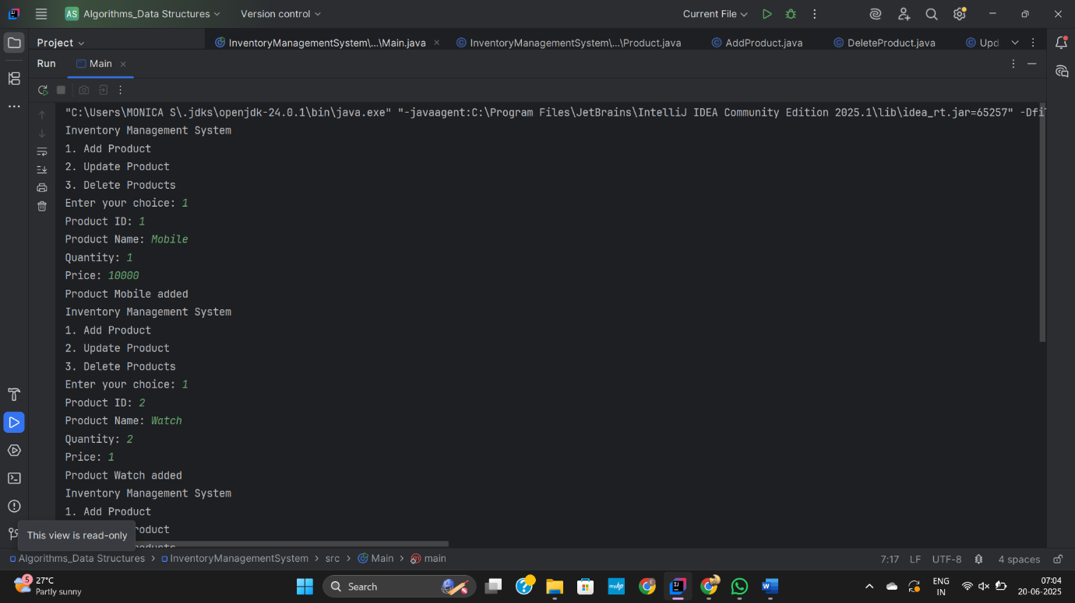

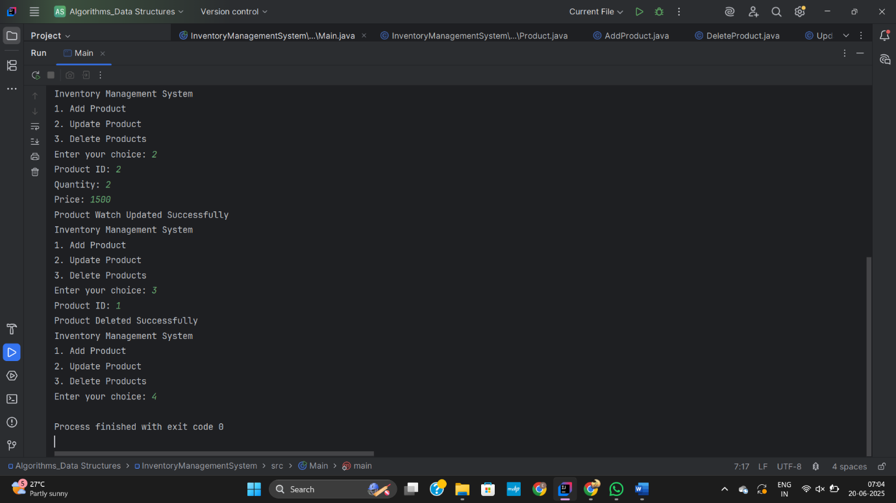

**2. E-commercePlatformSearchFunction**

**Main.java**

import java.util.Arrays;  
import java.util.Scanner;  
public class Main {  
 public static void main(String[] args) {  
 Scanner io=new Scanner(System.*in*);  
 LinearSearch l=LinearSearch.*getInstance*();  
 BinarySearch b=BinarySearch.*getInstance*();  
 int productId;  
 String productName;  
 String category;  
 int quantity;  
 double amount;  
 System.*out*.print("Enter number of Elements: ");  
 int n=io.nextInt();  
 Product[] product=new Product[n];  
 for(int i=0;i<n;i++) {  
 System.*out*.print("Product ID: ");  
 productId= io.nextInt();  
 System.*out*.print("Product Name: ");  
 productName=io.next();  
 System.*out*.print("Category: ");  
 category=io.next();  
 System.*out*.print("Quantity: ");  
 quantity=io.nextInt();  
 System.*out*.print("Amount: ");  
 amount=io.nextDouble();  
 Product p=new Product(productId, productName, category, quantity, amount);  
 product[i]=p;  
 System.*out*.println("Added successfully");  
 }  
 while (true) {  
 System.*out*.println("Searching Operation");  
 System.*out*.println("1. Linear search\n2. Binary search\n3. Exit");  
 System.*out*.print("Enter your choice: ");  
 int ch=io.nextInt();  
 switch (ch) {  
 case 1:  
 System.*out*.print("Search product: ");  
 productName=io.next();  
 System.*out*.println(l.linearSearch(product, productName));  
 break;  
 case 2:  
 System.*out*.print("Search product: ");  
 productName=io.next();  
 System.*out*.println(b.binary(product, productName));  
 break;  
 case 3:  
 System.*out*.println("Bye...");  
 return;  
 default:  
 System.*out*.println("Enter valid choice");  
 }  
 }  
 }  
}

**Product.java**

public class Product {  
 int productId;  
 String productName;  
 String category;  
 int quantity;  
 double amount;  
 public Product(int productId, String productName, String category, int quantity, double amount) {  
 this.productId=productId;  
 this.productName=productName;  
 this.category=category;  
 this.quantity=quantity;  
 this.amount=amount;  
 }  
}

**BinarySearch.java**

import java.util.Arrays;  
import java.util.Comparator;  
public class BinarySearch {  
 private BinarySearch() {  
 }  
 public static BinarySearch getInstance() {  
 return new BinarySearch();  
 }  
 public String binary(Product[] products, String name) {  
 Arrays.*sort*(products, new Comparator<Product>() {  
 public int compare(Product p1, Product p2) {  
 return p1.productName.compareToIgnoreCase(p2.productName);  
 }  
 });  
 int low = 0, high = products.length - 1;  
 while (low <= high) {  
 int mid = (low + high) / 2;  
 int compare = name.compareToIgnoreCase(products[mid].productName);  
 if (compare == 0)  
 return "Product ID: "+products[mid].productId+"\nProduct name: "+products[mid].productName+  
 "\ncategory: "+products[mid].category+"\nQuantity: "+products[mid].quantity+"\nPrice: "+products[mid].amount;  
 else if (compare < 0)  
 high = mid - 1;  
 else  
 low = mid + 1;  
 }  
 return null;  
 }  
}

**LinearSearch.java**

public class LinearSearch {  
 private LinearSearch() {  
 }  
 public static LinearSearch getInstance() {  
 return new LinearSearch();  
 }  
 public String linearSearch(Product[] products, String name) {  
 for (int i = 0; i < products.length; i++) {  
 if (products[i].productName.equalsIgnoreCase(name)) {  
 return "Product ID: "+products[i].productId+"\nProduct name: "+products[i].productName+  
 "\ncategory: "+products[i].category+"\nQuantity: "+products[i].quantity+"\nPrice: "+products[i].amount;  
 }  
 }  
 return null;  
 }  
}

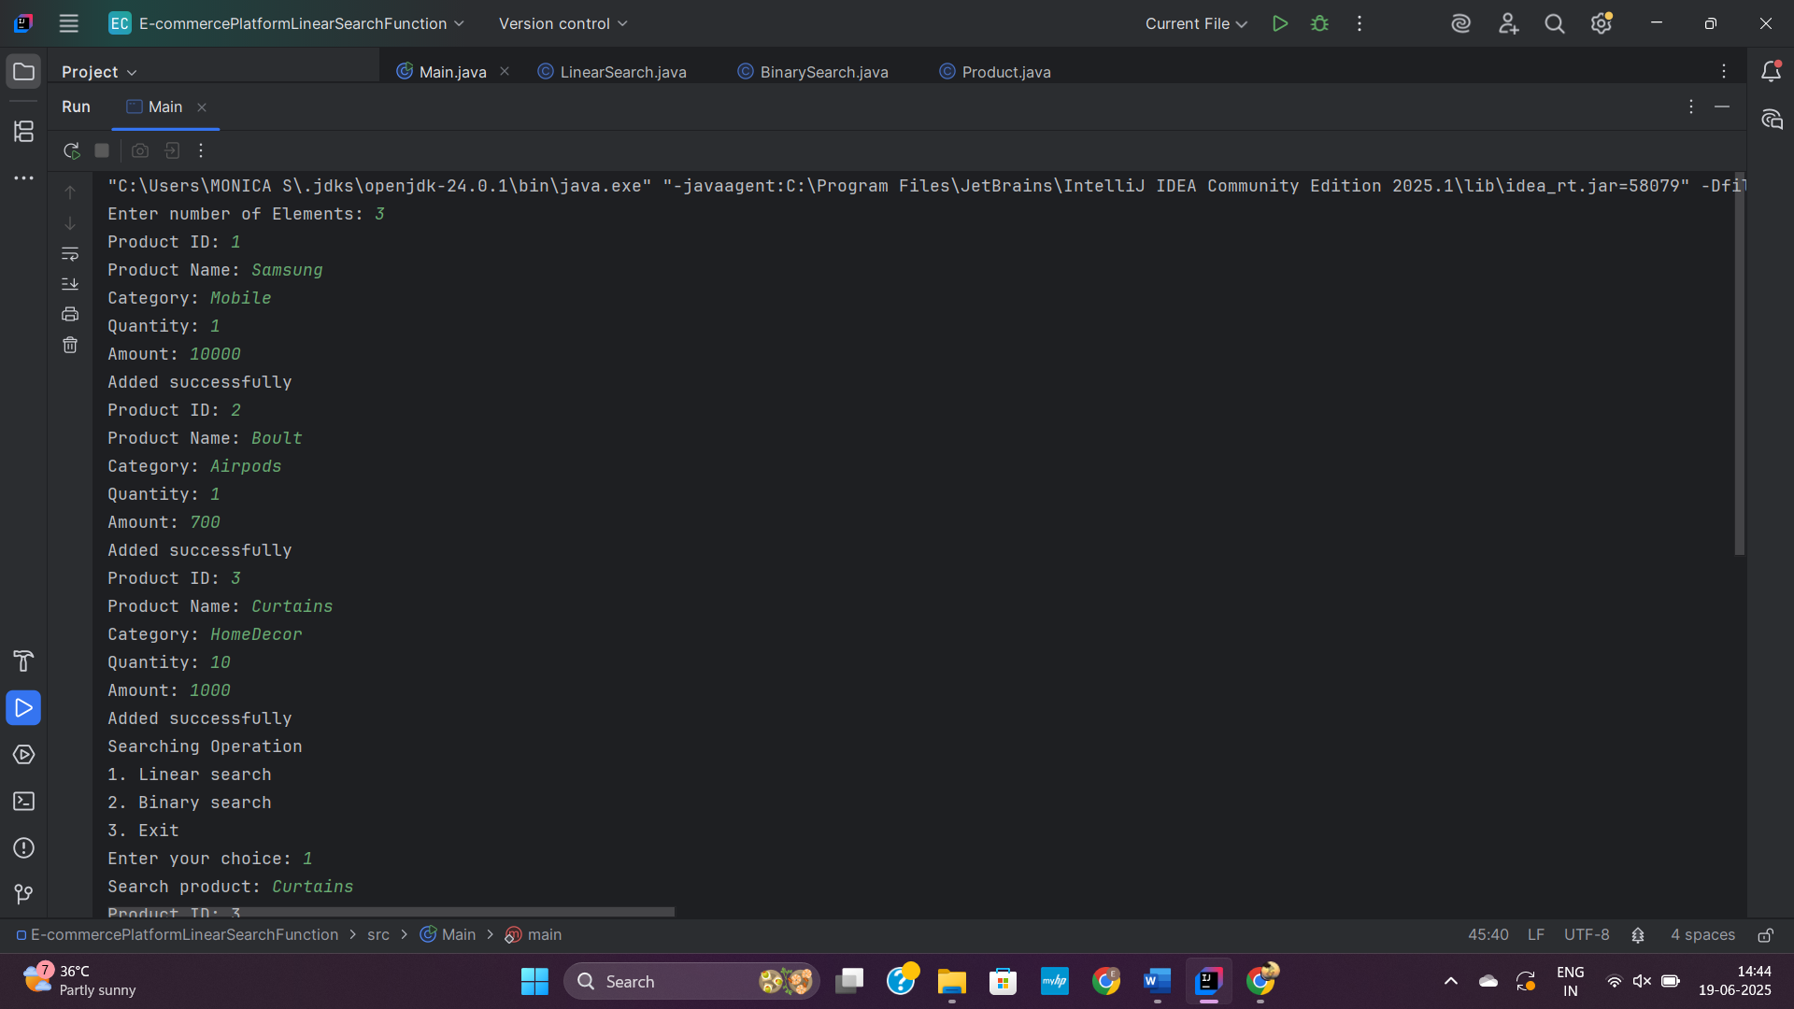

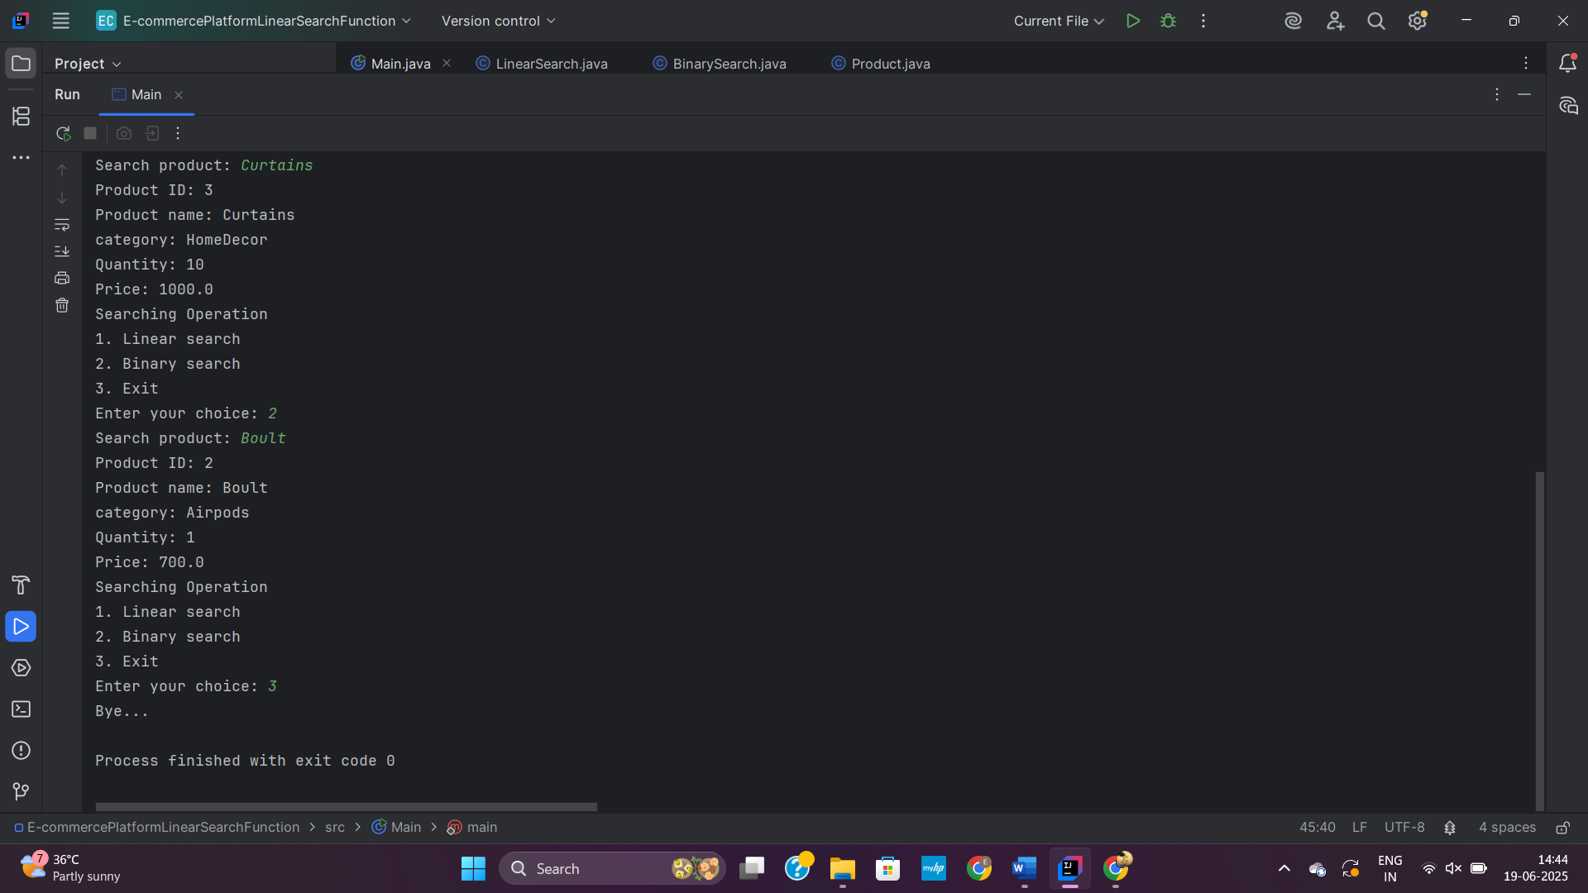

**3. SortingCustomerOrder**

**Main.java**

import java.util.Scanner;  
public class Main {  
 public static void main(String[] args) {  
  
 Scanner io=new Scanner(System.in);  
 int OrderId;  
 String OrderName;  
 double totalPrice;  
 System.out.print("Enter number of Orders: ");  
 int n=io.nextInt();  
 Order[] order=new Order[n];  
 for(int i=0;i<n;i++) {  
 System.out.print("Order ID: ");  
 OrderId=io.nextInt();  
 System.out.print("Order name: ");  
 OrderName=io.next();  
 System.out.print("Total price: ");  
 totalPrice=io.nextDouble();  
 Order o=new Order(OrderId, OrderName, totalPrice);  
 order[i]=o;  
 }  
 while (true) {  
 System.out.println("Sorting Operation");  
 System.out.println("1. Bubble sort\n2. Quick sort\n3. Exit");  
 System.out.print("Enter your choice(1/2/3): ");  
 int ch=io.nextInt();  
 switch (ch) {  
 case 1:  
 BubbleSort.sort(order);  
 break;  
 case 2:  
 QuickSort.sort(order, 0, n - 1);  
 System.out.println("Sorted using Quick Sort:");  
 QuickSort.printOrders(order);  
 break;

case 3:  
 System.out.println("Bye...");  
 return;  
 default:  
 }  
 }  
 }  
}

**Order.java**

public class Order {  
  
 int OrderId;  
 String OrderName;  
 double totalPrice;  
  
 public Order(int OrderId, String OrderName, double totalPrice){  
 this.OrderId=OrderId;  
 this.OrderName=OrderName;  
 this.totalPrice=totalPrice;  
 }  
  
}

**BubbleSort.java**

public class BubbleSort {  
 public static void sort(Order[] orders) {  
 int n=orders.length;  
 for (int i=0;i<n-1;i++) {  
 for (int j=0;j<n-i-1;j++) {  
 if(orders[j].totalPrice>orders[j+1].totalPrice){  
 Order temp=orders[j];  
 orders[j]=orders[j+1];  
 orders[j+1]=temp;  
 }  
 }  
 }  
 for(int i=0;i<n;i++) {  
 System.out.print("Order Id: "+orders[i].OrderId+" Order name: "+orders[i].OrderName+" Total Price\n");  
 }  
 }  
}

**QuickSort.java**

public class QuickSort {  
  
 public static void sort(Order[] orders, int low, int high) {  
 if (low < high) {  
 int pivotIndex = partition(orders, low, high);  
 sort(orders, low, pivotIndex - 1);  
 sort(orders, pivotIndex + 1, high);  
 }  
  
 }  
  
 private static int partition(Order[] orders, int low, int high) {  
 double pivot = orders[high].totalPrice;  
 int i = low - 1;  
  
 for (int j = low; j < high; j++) {  
 if (orders[j].totalPrice < pivot) {  
 i++;  
 Order temp = orders[i];  
 orders[i] = orders[j];  
 orders[j] = temp;  
 }  
 }  
  
 Order temp = orders[i + 1];  
 orders[i + 1] = orders[high];  
 orders[high] = temp;  
  
 return i + 1;  
 }  
  
 public static void printOrders(Order[] orders) {  
 for (Order o : orders) {  
 System.out.println("Order ID: " + o.OrderId + " Order Name: " + o.OrderName + " Total Price: " + o.totalPrice);  
 }  
 }  
}

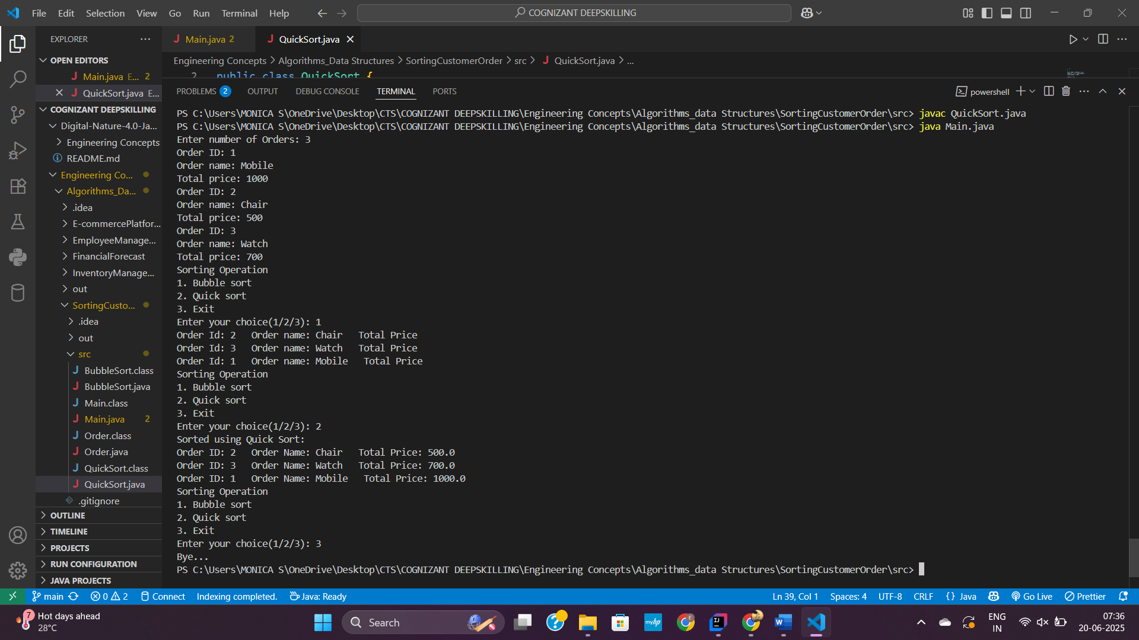

**4. Employee Management System**

**Main.java**

import java.util.Scanner;  
  
public class Main {  
 public static void main(String[] args) {  
 Scanner io = new Scanner(System.*in*);  
 EmployeeManagementSystem ems = new EmployeeManagementSystem();  
  
 while (true) {  
 System.*out*.println("\nEmployee Management System:");  
 System.*out*.println("1. Add Employee");  
 System.*out*.println("2. Delete Employee");  
 System.*out*.println("3. Search Employee");  
 System.*out*.println("4. Display All Employees");  
 System.*out*.println("5. Exit");  
 System.*out*.print("Enter your choice: ");  
 int choice = io.nextInt();  
  
 switch (choice) {  
 case 1:  
 System.*out*.print("Employee ID: ");  
 int id = io.nextInt();  
 System.*out*.print("Name: ");  
 String name = io.next();  
 System.*out*.print("Position: ");  
 String position = io.next();  
 System.*out*.print("Salary: ");  
 double salary = io.nextDouble();  
  
 Employee newEmp = new Employee(id, name, position, salary);  
 ems.addEmployee(newEmp);  
 break;  
  
 case 2:  
 System.*out*.print("Employee ID: ");  
 int delId = io.nextInt();  
 ems.deleteEmployee(delId);  
 break;  
  
 case 3:  
 System.*out*.print("Employee ID: ");  
 int searchId = io.nextInt();  
 Employee found = ems.searchEmployee(searchId);  
 if (found != null) {  
 found.displayInfo();  
 } else {  
 System.*out*.println("Employee not found.");  
 }  
 break;  
  
 case 4:  
 ems.listEmployees();  
 break;  
  
 case 5:  
 System.*out*.println("Bye..");  
 System.*exit*(0);  
  
 default:  
 System.*out*.println("Invalid choice.");  
 }  
 }  
 }  
}

**Employee.java**

public class Employee {  
 int employeeId;  
 String name;  
 String position;  
 double salary;  
  
 public Employee(int employeeId, String name, String position, double salary) {  
 this.employeeId = employeeId;  
 this.name = name;  
 this.position = position;  
 this.salary = salary;  
 }  
  
 public void displayInfo() {  
 System.*out*.println("ID: " + employeeId + ", Name: " + name +  
 ", Position: " + position + ", Salary: " + salary);  
 }  
}

**EmployeeManagementSystem.java**

public class EmployeeManagementSystem {  
 Employee[] employees = new Employee[100];  
 int count = 0;  
 public void addEmployee(Employee emp) {  
 if (count < employees.length) {  
 employees[count++] = emp;  
 } else {  
 System.*out*.println("Employee array is full!");  
 }  
 }  
 public Employee searchEmployee(int id) {  
 for (int i = 0; i < count; i++) {  
 if (employees[i].employeeId == id) {  
 return employees[i];  
 }  
 }  
 return null;  
 }  
 public void listEmployees() {  
 for (int i = 0; i < count; i++) {  
 employees[i].displayInfo();  
 }  
 }  
 public void deleteEmployee(int id) {  
 for (int i = 0; i < count; i++) {  
 if (employees[i].employeeId == id) {  
 for (int j = i; j < count - 1; j++) {  
 employees[j] = employees[j + 1];  
 }  
 employees[--count] = null;  
 System.*out*.println("Employee deleted.");  
 return;  
 }  
 }  
 System.*out*.println("Employee not found.");  
 }  
}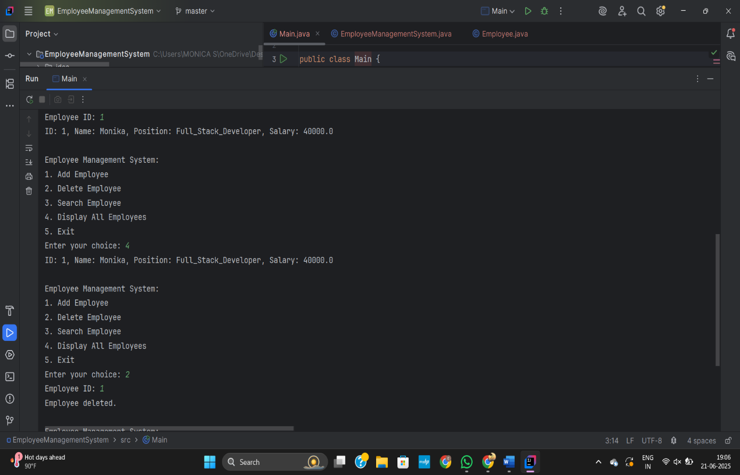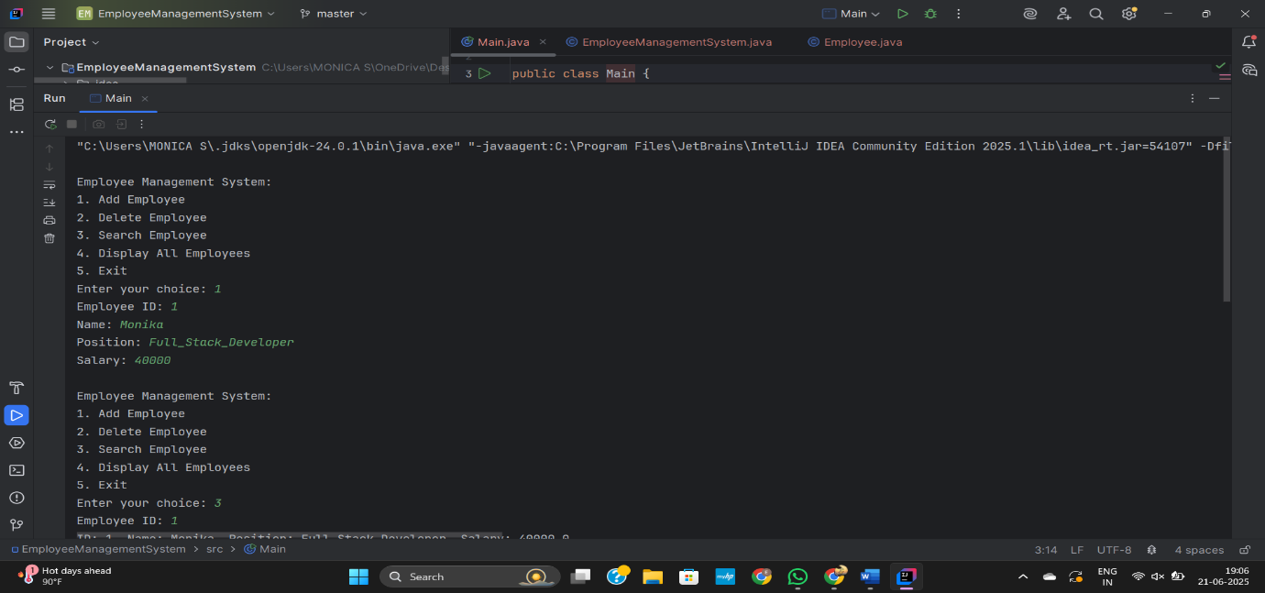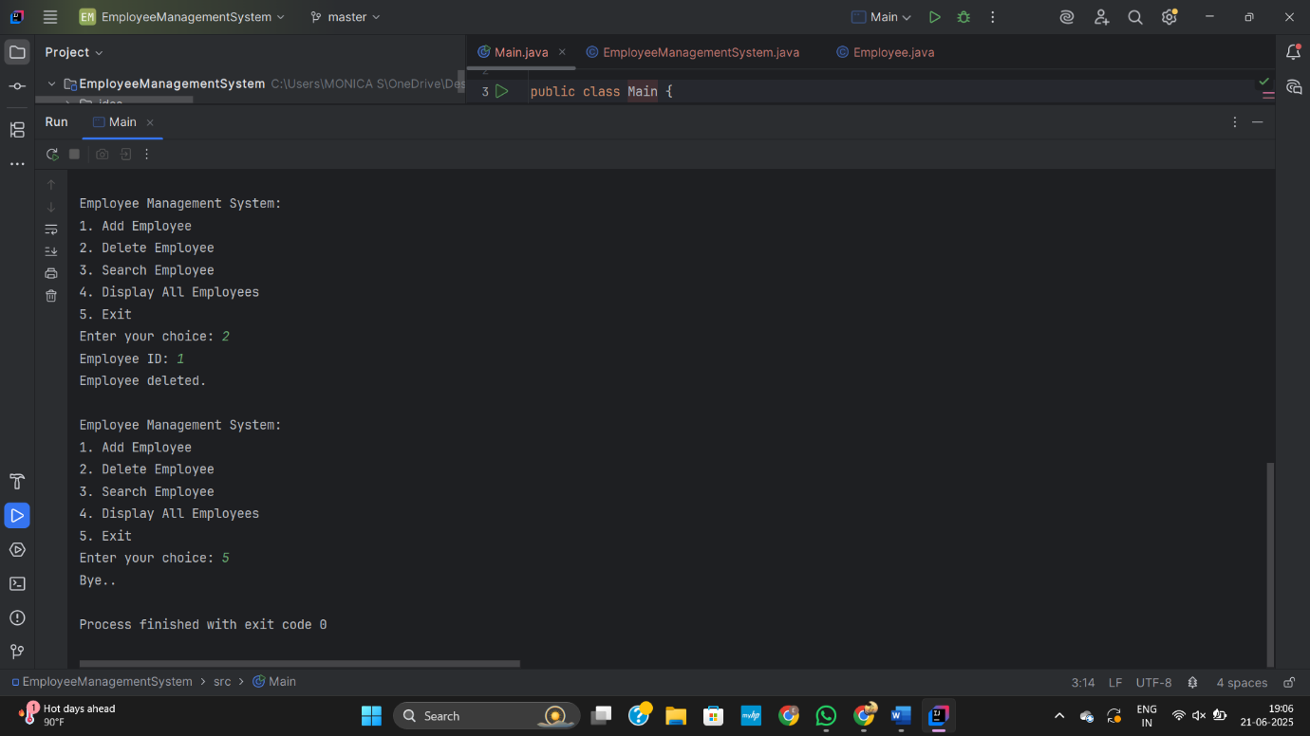

**5. TaskManagementSystem**

**Main.java**

import java.util.Scanner;  
public class Main {  
 public static void main(String[] args) {  
 Scanner io=new Scanner(System.in);  
 int taskId;  
 String taskName;  
 String status;  
 while (true) {  
 System.out.println("Task Management System" +  
 "\n1. Add" +  
 "\n2. Delete" +  
 "\n3. Traverse" +  
 "\n4. Search");  
 System.out.print("Enter your choice: ");  
 int ch=io.nextInt();  
 switch (ch) {  
 case 1:  
 System.out.print("Task ID: ");  
 taskId=io.nextInt();  
 io.nextLine();  
 System.out.print("Task Name: ");  
 taskName=io.nextLine();  
 System.out.print("Status: ");  
 status=io.nextLine();  
 Node.add(taskId,taskName,status);  
 break;  
 case 2:  
 System.out.print("Task ID to delete: ");  
 taskId=io.nextInt();  
 Node.delete(taskId);  
 break;  
 case 3:  
 Node.display();  
 break;  
 case 4:  
 System.out.print("Task ID: ");  
 taskId=io.nextInt();  
 Node.search(taskId);  
 break;  
 default:  
 System.out.println("Enter valid choice");  
 }  
 }  
 }  
}

**Node.java**

public class Node {  
 Task data;  
 Node next;  
 static Node head = null;  
  
 public Node(Task data) {  
 this.data = data;  
 this.next = null;  
 }  
  
 public static void add(int taskId, String taskName, String status) {  
 Task t = new Task(taskId, taskName, status);  
 Node newNode = new Node(t);  
  
 if (head == null) {  
 head = newNode;  
 } else {  
 Node curr = head;  
 while (curr.next != null) {  
 curr = curr.next;  
 }  
 curr.next = newNode;  
 }  
  
 System.out.println("Task Added Successfully");  
 }  
  
 public static void delete(int taskId) {  
 if (head == null) {  
 System.out.println("Empty Task List");  
 return;  
 }  
 if (head.data.taskId == taskId) {  
 head = head.next;  
 System.out.println("Task deleted successfully.");  
 return;  
 }  
 Node curr = head;  
 Node prev = null;  
  
 while (curr != null && curr.data.taskId != taskId) {  
 prev = curr;  
 curr = curr.next;  
 }  
  
 if (curr == null) {  
 System.out.println("Task not found.");  
 } else {  
 prev.next = curr.next;  
 System.out.println("Task deleted successfully.");  
 }  
 }  
  
 public static void display() {  
 if (head==null) {  
 System.out.println("Empty Task list");  
 return;  
 }  
 Node curr=head;  
 while (curr!=null) {  
 System.out.println(curr.data.taskId+"->"+curr.data.taskName+"->"+curr.data.status);  
 curr=curr.next;  
 }  
 }  
 public static void search(int taskId) {  
 if(head==null) {  
 System.out.println("Empty Task List");  
 return;  
 }  
 Node curr=head;  
 while (curr!=null) {  
 if(curr.data.taskId==taskId) {  
 System.out.println(head.data.taskId+"->"+head.data.taskName+"->"+head.data.status);  
 return;  
 }  
 curr=curr.next;  
 }  
 }  
}

**Task.java**

public class Task {  
 int taskId;  
 String taskName;  
 String status;  
 public Task(int taskId, String taskName, String status) {  
 this.taskId=taskId;  
 this.taskName=taskName;  
 this.status=status;  
 }  
}

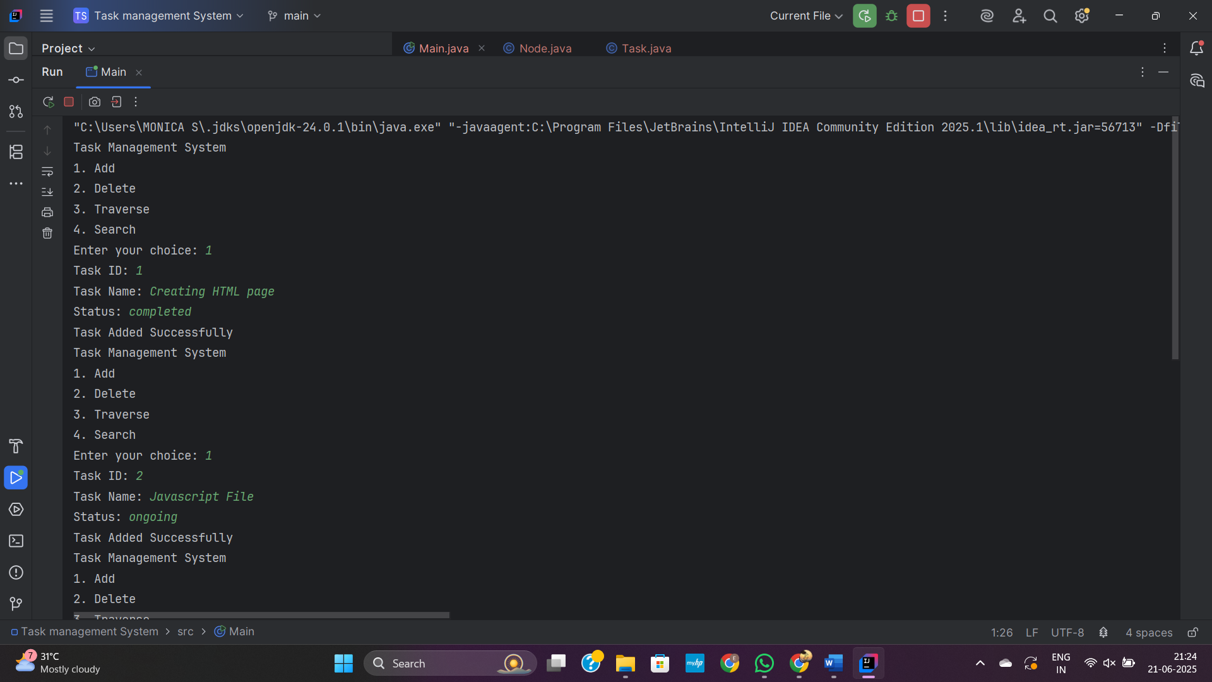

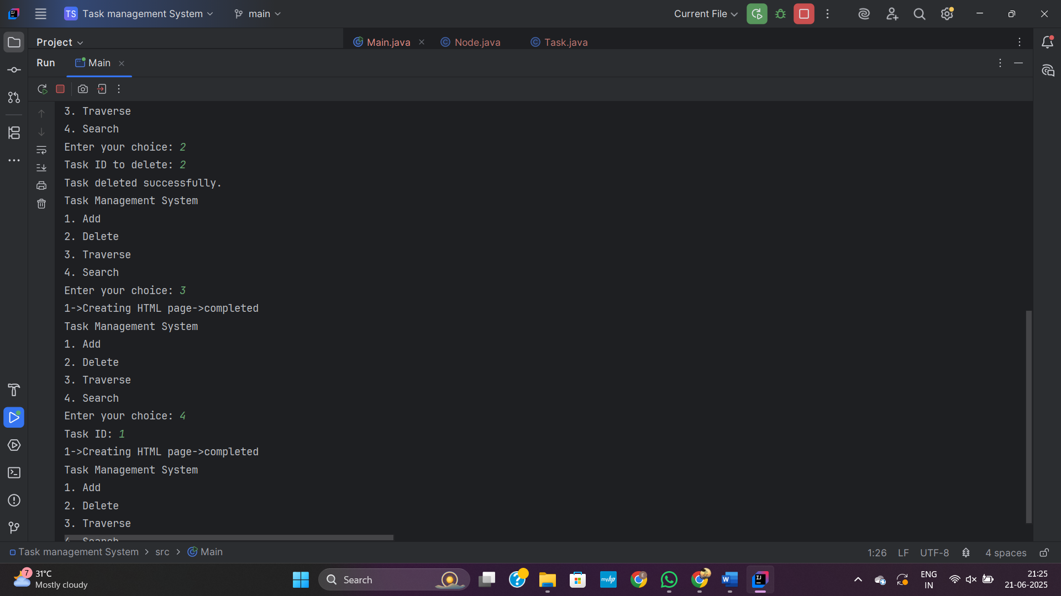

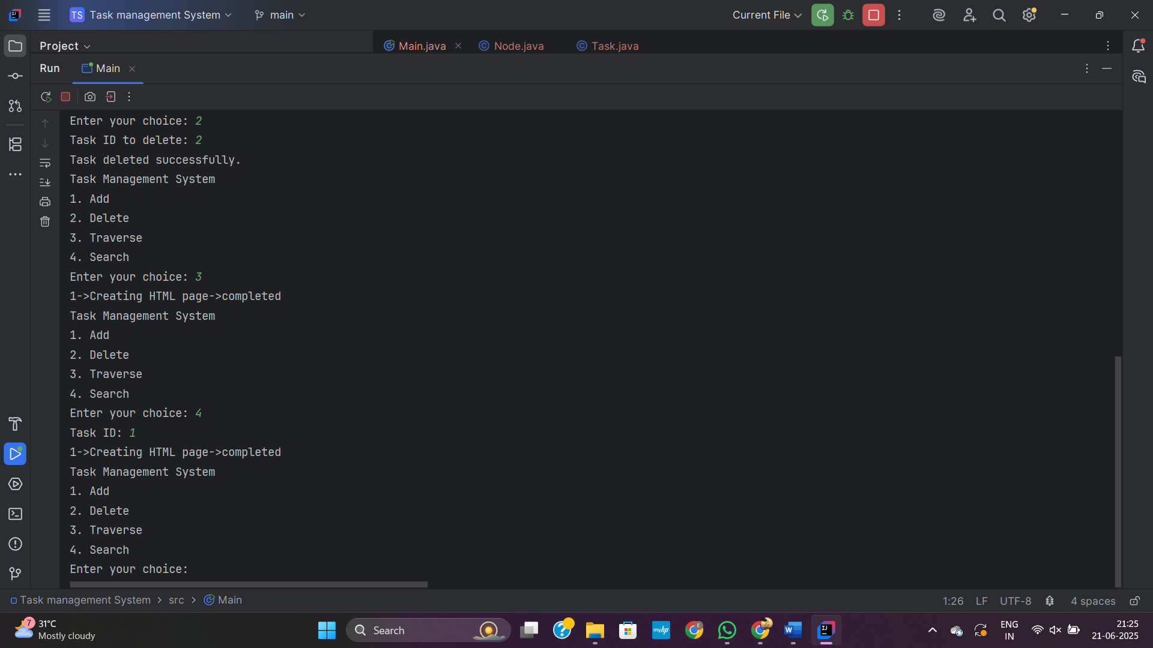

**6. LibraryManagementSystem**

**BinarySearch.java**

import java.util.Arrays;  
import java.util.Comparator;  
  
public class BinarySearch {  
 public static void searchByTitle(Book[] b, String title) {  
 Arrays.sort(b, Comparator.comparing(a->a.title.toLowerCase()));  
 int n=b.length;  
 int low=0, high=n-1;  
 while (low<=high) {  
 int mid=(low+high)/2;  
 int cmp=b[mid].title.compareToIgnoreCase(title);  
 if(cmp==0){  
 System.out.println("Book ID: "+b[mid].bookId+  
 "\nTitle: "+b[mid].title+  
 "\nAuthoer: "+b[mid].author);  
 System.out.println("---------------------------");  
 }  
 if(cmp>0) {  
 high=mid-1;  
 }  
 else{  
 low=mid+1;  
 }  
 }  
 }  
}

**Book.java**

public class Book {  
 int bookId;  
 String title;  
 String author;  
  
 public Book(int bookId, String title, String author) {  
 this.bookId = bookId;  
 this.title = title;  
 this.author = author;  
 }  
}

**LinearSearch.java**

public class LinearSearch{  
  
 public static void searchByTitle(Book[] books, String title) {  
 int n=books.length;  
 for (int i=0;i<n;i++) {  
 if(books[i].title.equalsIgnoreCase(title)) {  
 System.out.println("Book ID: "+books[i].bookId+  
 "\nTitle: "+books[i].title+  
 "\nAuthoer: "+books[i].author);  
 System.out.println("---------------------------");  
  
 }  
 }  
 }  
}

**Main.java**

import java.util.Scanner;  
public class Main {  
 public static void main(String[] args) {  
  
 Scanner io=new Scanner(System.in);  
 System.out.print("Number of Books: ");  
 int n=io.nextInt();  
 Book books[]=new Book[n];  
 for (int i=0;i<n;i++) {  
 System.out.print("Book ID: ");  
 int bookId= io.nextInt();  
 io.nextLine();  
 System.out.print("Title: ");  
 String title=io.nextLine();  
 System.out.print("Author: ");  
 String author=io.nextLine();  
 Book b=new Book(bookId, title, author);  
 books[i]=b;  
 }  
 System.out.print("Enter title to search: ");  
 String find=io.next();  
 System.out.println("Linear Search");  
 LinearSearch.searchByTitle(books, find);  
 System.out.println("Binary Search");  
 BinarySearch.searchByTitle(books, find);  
 }  
}

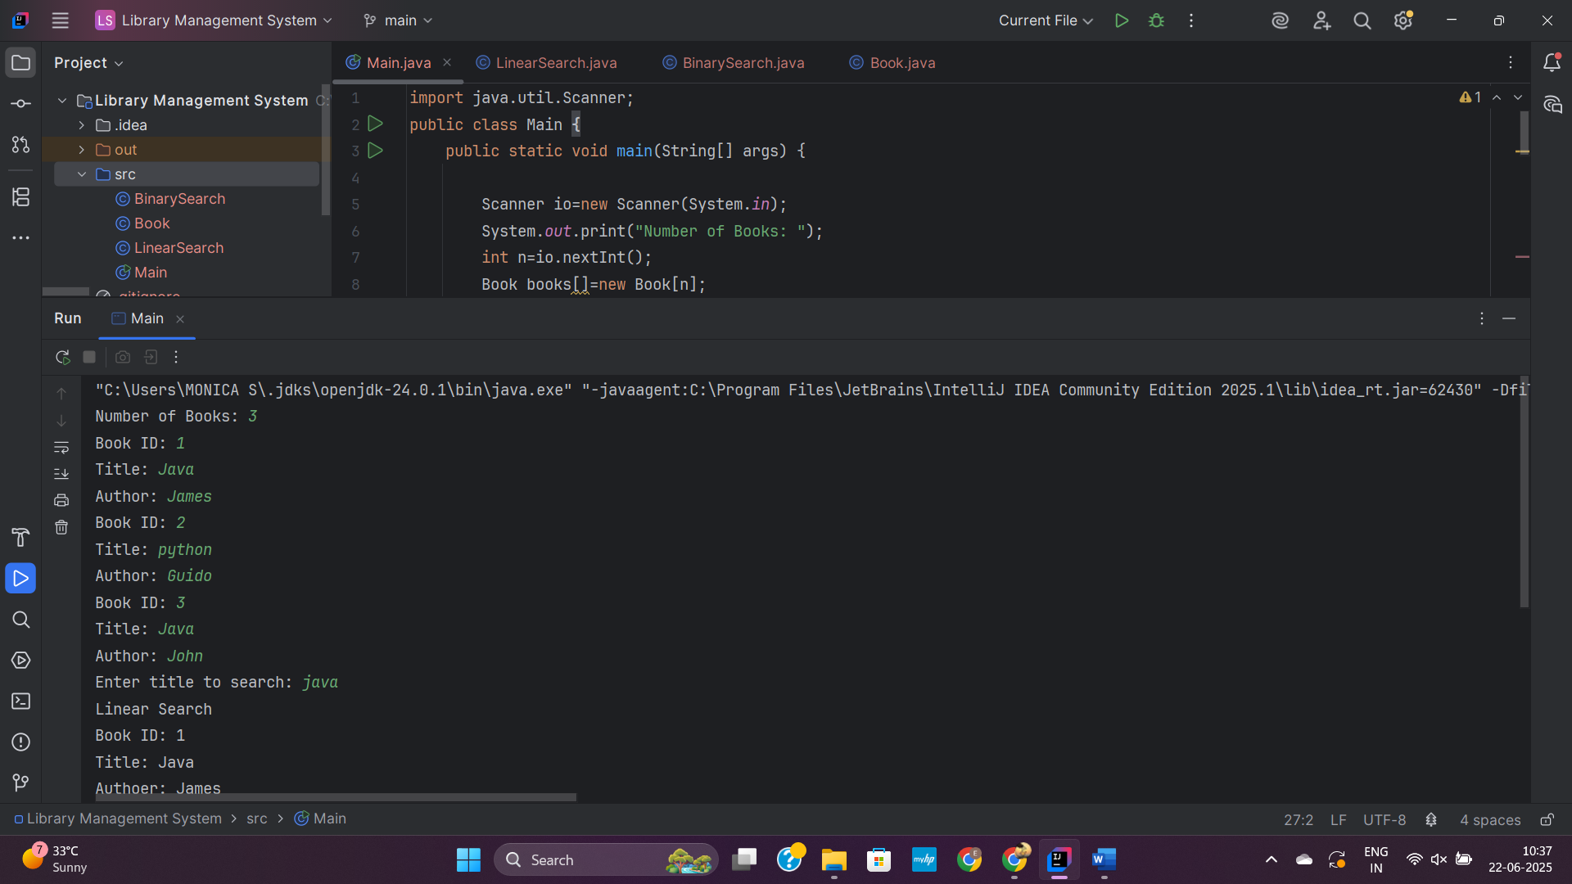

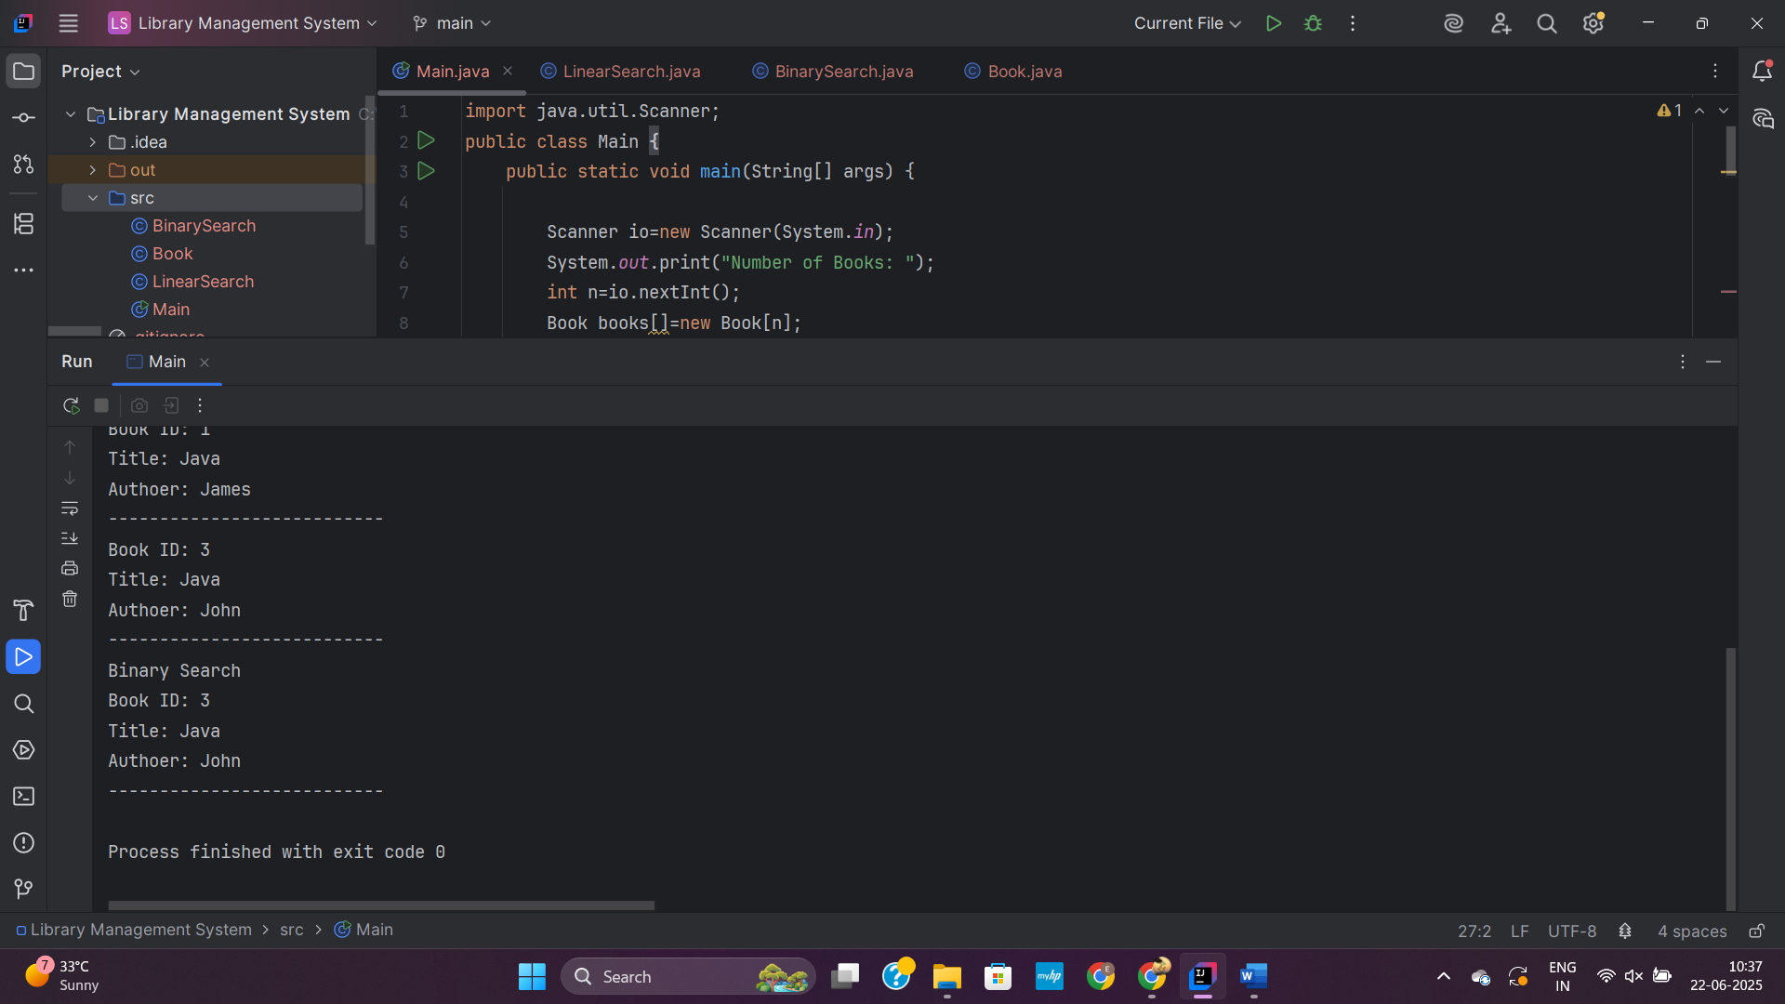

**7. FinancialForecast**

**Main.java**

import java.util.Scanner;  
  
public class Main {  
 public static void main(String[] args) {  
 Scanner io=new Scanner(System.in);  
 System.out.print("Current value: ");  
 double currentValue = io.nextDouble();  
 System.out.print("Growth Value: ");  
 double growthRate = io.nextDouble();  
 System.out.print("Years: ");  
 int years = io.nextInt();  
  
 double futureValue = futureValue(currentValue, growthRate, years);  
 System.out.printf("Future value after %d years = ₹%.2f", years, futureValue);  
 }  
  
 private static double futureValue(double currentValue, double growthRate, int years) {  
 if (years == 0) {  
 return currentValue;  
 } else {  
 return futureValue(currentValue, growthRate, years - 1) * (1 + growthRate);  
 }  
 }  
}

